ECE Senior Design Weekly Report

**Engineer’s Name:** Leon Tran             **Date:** 03/08/17

**Team Name:** The Globetrotters **Lab Section:** 4

**Week’s Task:** Display the relevant information onto the map, Integrate the QGIS Platform onto the Raspberry PI, and started Researching into Physical Rotation

**Results:**

* **QGIS Map**
  + Displays the information through HTML
    - 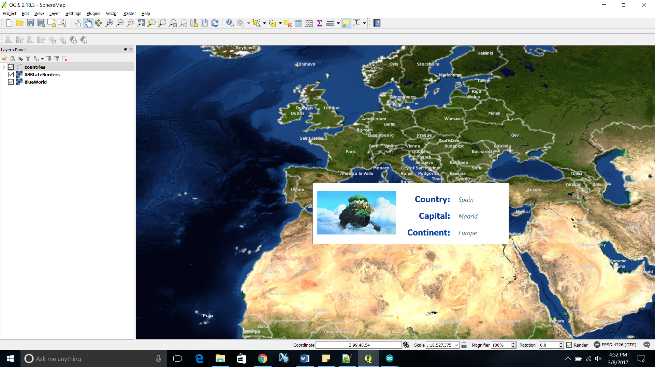
    - Translated it over to the Raspberry PI. There are some formatting issues, but I’m researching ways to resolve them.
  + Raspberry PI Integration
    - Major issues that I encountered was with the rendering rate.
      * It takes up 84 % of the CPU when I was moving from one location to another
      * I’m currently researching ways to decrease the amount of data that must be rendered at once.
        + Currently use multiple cores to render the map images, it helps, but still requires a lot of processing.
* Physical Rotation
  + Motor inside Globe
    - Inductive Coupling and Resonant Power Transfer is a viable option for a power source. Its wireless and will require less weight than a battery
    - Gyroscope & Accelerometer to help control stability